**Applied Project**

**MASY-GC4100| 103 | Spring 2024 | 1/25/2024 - 5/2/2024 | 3 Credits**

**Modality:** In Person

**Course Site URL:** <https://brightspace.nyu.edu/>

**General Course Information**

**Name/Title:** Dr. Andres Fortino, Clinical Associate Professor, He/Him/His

**NYU Email:** agf249@nyu.edu

**Class Meeting Schedule:** 1/25/2024 - 5/2/2024/ Thursday | 6:20 PM - 8:55 PM

**Class Location:** Midtown Room 526

**Office Hours:** By Appointment, method: NYU Zoom

**Description**

Where academically warranted and subject to departmental approval, the student will undertake and deliver a real-world project for active practitioners in the field. Under the direction of a faculty supervisor, the student will select and explore a topic to be developed. The student will then be required to generate a practical application of his/her findings that demonstrates professional-level mastery of the subject matter involved. The project will be reviewed by the faculty supervisor and possibly one other expert in the field.

**Prerequisites**

All Core Courses - MASY1-GC: 1200, 1210, 1220, 1230, 1240,1250, 1260, 3310.

**Learning Outcomes**

At the completion of this course, students will be able to:

* Design a project proposal that will be used to initiate, conduct, and complete an Applied Project (completed within the initial 6-week remote course timeframe).
* Design a situational analysis.
* Generate a literature survey (completed by Week 8).
* Design a project charter and associated work breakdown structure (WBS), risk analysis and organizational change management plan (completed within the initial 6-week synchronous course timeframe).
* Select a Project Sponsor who is a management-level individual at the organization benefitting from the Applied Project. The Project Sponsor must have the authority to approve the student's Project Proposal and any required resources and be available throughout the project to act as the student's mentor for the project. The Project Sponsor will also be asked to approve in writing the student's work at key intervals throughout the course and the ensuing project and be available for at least one meeting (virtual or in-person) with the course professor.
* Design a project goal and a set of project objectives that will include metrics for demonstrating project success (completed within the initial 6-week remote course timeframe).
* Conduct an Applied Project while operating in the dual role of (a) Project Manager employing the Project Management Body of Knowledge methodology and (b) Project Implementer, successfully meeting the project goal and objectives all within the timeframe set forth in the project plan section of the project proposal. (This will extend beyond the initial 6-week remote course timeframe).
* Write a post-project final report describing the project, its planning phase, and its implementation phase.

**Communication Methods**

This course will use the NYU Brightspace LMS for the delivery of course materials and for course communications.

Important course information, announcements, updates, course presentations and other materials will be posted on the NYU Brightspace LMS. Course announcements will also be simultaneously forwarded by the NYU Brightspace LMS to students' NYU email addresses.

Students are expected and required to be aware of any such announcements or communications and are advised to check the announcements as well as their NYU email address regularly during the 14-week duration of the course as well as afterward while conducting their Applied Project.

Students must use their NYU email to communicate. NYU Brightspace LMS course-mail supports student privacy and FERPA guidelines.

The instructor’s email address is agf249@nyu.edu and it is checked regularly and frequently; students will usually receive a reply within 12 hours during the workweek. The instructor does not have access to an NYU telephone number.

The instructor will conduct office hours using Zoom, by telephone, or in-person at the NYU campus—by appointment. If you would like to schedule a meeting, please send an email to the instructor at least two days prior to the date you would like to meet. You should also suggest an alternative date in case the first date is not available. Discussions through online platforms will require that you have speakers and a microphone. A video camera is highly recommended.

Students have the opportunity to add their pronouns, as well as the pronunciation of their names, into Albert. Students can have this information displayed to faculty in Albert, Brightspace, and other NYU systems. Students can also opt-out of having their pronouns viewed by their instructors.

<https://www.nyu.edu/students/student-information-and-resources/registration-records-and-graduation/forms-policies-procedures/change-of-student-information/pronouns-and-name-pronunciation.html>

**Structure | Method | Modality**

The course is scheduled for 14-weeks, with the first 7-weeks devoted to learning activities as a group. Each student will prepare their own individual deliverables relating directly to each student’s project. Each student’s work will thus be evaluated individually by the instructor with appropriate feedback as needed.

At the end of the initial 7-weeks in-person in-class sessions, the course professor meets individually with each student and sponsor team to review the project goal, objectives, and metrics as well as the entire project plan (Project Charter, Situational Analysis Work Breakdown Structure, communications plan, risk management plan, etc.). During this time, the instructor will provide additional lessons in an asynchronous (pre-recorded) format. These final 7-weeks are also dedicated to individual mentoring conferences between the professor and each individual student to monitor progress and guide the student in their project activities.

The course will be conducted in a hybrid fashion utilizing a combination of in-person sessions and pre-recorded (asynchronous) sessions. Asynchronous sessions (pre-recorded) will be made available via NYU Brightspace. A URL link to each recording will be provided once the session has been recorded. The schedule of sessions will also be posted on the course’s NYU Brightspace LMS.

During the first 7-week period of formal instruction comprising the course, the student will learn how to define project objectives and metrics and how to plan and manage a real-world applied project. Course sessions will be conducted in person at the designated location and be simultaneously available synchronously on NYU Zoom, which you can access from the course site in [NYU Brightspace](https://brightspace.nyu.edu/).

**Expectations**

Learning Environment

You play an important role in creating and sustaining an intellectually rigorous and inclusive classroom culture. Respectful engagement, diverse thinking, and our lived experiences are central to this course, and enrich our learning community.

Participation

You are integral to the learning experience in this class. Be prepared to actively contribute to class activities, group discussions, and work outside of class.

As graduate students, you are expected to conduct yourselves in a professional manner and engage and collaborate with your classmates. SPS classrooms are diverse and include students who range in age, culture, learning styles, and levels of professional experience. To maintain an inclusive environment that ensures all students can equally participate with and learn from each other, as well as receive feedback and instruction from faculty during group discussions in the classroom, all course-based discussions and group projects should occur in a language that is shared among all participants.

The Use of AI

Students should actively yet thoughtfully utilize AI writing assistance to help draft and develop their work, but must thoroughly and critically review any AI output, refine arguments as needed to meet their own standards and take full ownership of final submissions, being able to stand behind the work as their own.

Learning to use Al is an important skill, and we will provide tutorials on how to use it in each lesson. Be aware of the limits of ChatGPT:

* If you provide minimum effort prompts, you will get low-quality results. You will need to refine your prompts in order to get good outcomes. This will take work.
* Don't trust anything it says. If it gives you a number or fact, assume it is wrong unless you either know the answer or can check in with another source. You will be responsible for any errors or omissions provided by the tool. It works best for topics you understand.
* Be thoughtful about when this tool is useful. Only use it if it is appropriate for the case or circumstance.

Assignments and Deadlines

Each student will work under the direction of a project sponsor who is a management-level individual in the “client” organization for which the project is being conducted, who has both the responsibility and the authority to approve the project and any required resources, mentor the student, and review and approve all project deliverables such as project plans, project progress, status reports, and the final project report. The course professor will oversee the student’s progress and offer mentoring to the student during the course duration and afterward as the project progresses.

In order to qualify for entry into this course, students must have an approved project—i.e., the project has been pre-approved by the course professor prior to the start of the course. The student proposes a project idea and the student’s project proposal outline must be approved by the course professor prior to the student's entry into the course.

Students prepare a project outline utilizing an instructor-provided template, which describes the project in sufficient detail for the evaluator to accept or reject the project idea. A rejection will usually be accompanied with feedback and suggestions for the student to modify the proposal outline, where feasible.

Each student will prepare a written proposal document that describes the target environment, the details of the project and the goal and objectives of the project. The proposal will be used to recruit a project sponsor within the client organization who will act as the “client” manager for the student during the project. The word “client” does not imply that any monetary payments will be made for the student’s work—although 3 credits will be awarded upon successful completion of the course and all deliverables (see next paragraph).

Students will learn to develop a project goal and a set of objectives and related metrics for measuring the eventual achievement of those objectives once the applied project has been completed.

Students conduct a situational analysis to understand the components of the environment in which the organization operates and in which the project will be conducted, the industry the business is part of the competitors against whom the business competes, and the business’s own culture using tools such as Porter's 5-forces Model.

This is followed by a literature survey that is conducted by each student to learn about best practices, case studies, papers, and other information artifacts that can be leveraged to understand the optimal approach to conducting the applied project to achieve the desired results.

Students will develop a project charter that will be used to describe the approach, methodology, resources, timelines, and milestones of the project fully. A project management work breakdown structure will be constructed to plan the project deliverables and the activities and resources necessary to achieve each deliverable.

These deliverables must be approved and signed off by the Project Sponsor.

Once the above initial 7-week group instruction period is concluded, each student will embark upon his/her applied project within the "client" organization. Subsequently, for the remaining.

During the last 7-weeks of the course, the professor will schedule individual mentoring conferences with each student to ensure the successful startup and initiation of the student’s project. Since each individual project is unique, these individualized mentoring sessions will be held individually, without the entire class present.

This course requires each student to complete their project within the same semester in which they began, i.e., at the end of the full 14-week course. The exact due date by which the final report must be submitted will be published in the course website.

Individual projects and final reports are subject to the completion dates for each semester as published elsewhere in the course, and subject to SPS and NYU regulations.

Students are required to file a monthly project status report throughout the duration of their project, using a format specified during the course. The status report should be signed by the student and the student's project sponsor—signed documents can be submitted as PDF scans.

Assignment drop-boxes will be provided on the NYU Brightspace LMS course site for monthly status reports and all other course deliverables. Any assignment delivered up to one week late will receive a 25% penalty. After the first week of lateness and up to the last day of class, any assignment submitted in that period will be penalized 50% of the assigned grade.

At the completion of the student’s applied project, each student will write a mandatory final report paper describing the project and demonstrating the achievement of the project goals and each of the objectives as measured by the metrics developed during the planning stage. The final report must cover the items listed in the final report template document published elsewhere in the course. The project sponsor must sign off on the achievement of the project goal and each objective at the planned metric level and attest to the successful completion of the project.

Final Report: Upon completion of their project, each student must submit a final report describing their project and its results. A complete guidelines document will explain what is to be included in the final report. The paper should be in the range of 50 pages, minimum, not including appendices.

Once the final paper has been graded and accepted by the instructor, the student will have completed the course requirements, provided that all course deliverables (assignments) have also been satisfactorily completed.

See the outline for assignment due dates.

Course Technology Use

We will utilize multiple technologies to achieve the course goals. I expect you to use technology in ways that enhance the learning environment for all students. All class sessions require use of Zoom.All class sessions require use of technology (e.g., laptop, computer lab) for learning purposes.

Feedback and Viewing Grades

I will provide timely meaningful feedback on all your work via our course site in NYU Brightspace. You can access your grades on the course site Gradebook.

Attendance

Students are expected to attend all on-line class sessions. Excused absences are granted in cases of documented serious illness, family emergency, religious observance, or civic obligation. In the case of religious observance or civic obligation, this should be reported in advance. Unexcused absences from sessions may have a negative impact on a student’s final grade. Students are responsible for assignments given during any absence.

If for some reason (excused absence) you will not be in class, you must notify the instructor prior to the scheduled session if you will not be attending and the reason.

Each unexcused absence or being late may result in a student’s grade being lowered by a fraction of a grade. A student who has three unexcused absences may earn a Fail grade.

Refer to the [SPS Policies and Procedures page](https://www.sps.nyu.edu/homepage/student-experience/policies-and-procedures.html) for additional information about attendance.

**Textbooks and Course Materials**

**Required:**

* A Guide to the Project Management Body of Knowledge (PMBOK® Guide) - 6th edition, by Project Management Institute (PMI), 2017. ISBN-13: 978-1628251845, ISBN-10:9781628251845. Available from Amazon.com as a paperback book or as a Kindle eBook.

This book is also available as a free viewable eBook via NYU Home (home.nyu.edu), as follows: Select the “Research” tab and then search for “PMBOK” or “Project Management Body of Knowledge.” Select the fifth (or later) Edition. The book can be viewed and read but not downloaded.

* Ng, J. (2024). Mastering IT innovation: 90-day proof of value blueprint. Sage Ensights LLC.

**Software:**

* **Required ChatGPT v4 4Plus,** <https://openai.com/blog/chatgpt/>
* **Required Calude 3.5 Sonnet,** https://claude.ai/new

Additional required and optional readings will be posted to the NYU Brightspace LMS during the course. These will be case studies or other tutorial materials linked from the Internet.

**Grading | Assessment**

Your grade in this course is based on your performance on multiple activities and assignments. Since all graded assignments are related directly to course objectives and learning outcomes, failure to complete any assignment will result in an unsatisfactory course grade. All written assignments are to be completed using APA format and must be typed and double-spaced. Grammar, punctuation, and spelling will be considered in grading. Please carefully proof-read your written assignments before submitting them for a grade. I will update the grades on the course site each time a grading session has been completed— typically three (3) days following the completion of an activity.

The student will undertake and deliver a real-world project for active practitioners in the field. Under the direction of a faculty supervisor, the student will select and explore a topic to be developed. The student will then be required to generate a practical application of his/her findings that demonstrates professional-level mastery of the subject matter involved. The project will be reviewed by the faculty supervisor and one other expert in the field.

In addition to the array of opportunities for networking and applied learning provided by the M.S. in Management and Systems program, the applied project offers a truly singular opportunity to give back to your community through your newly honed technical and management skills. The project offers you the chance to work with a startup company or nonprofit organization or business enterprise and propose a solution to a real business need. Each year, the program partners with nonprofit organizations to design student projects that not only advance your business acumen and technological skills, but also further your commitment to social responsibility.

This capstone course will give students the opportunity to demonstrate mastery of the Management and Systems subject matter by conducting a real-world applied project for a real-world organization that brings real-world business value. The project will also serve as a means of acquiring additional knowledge and expertise in one or more of the knowledge domains covered in the Management and Systems M.S. program. Students plan, conduct, and implement the applied project and act in a dual-role capacity:

* the project manager and
* the project implementer.

Student projects follow the internationally recognized standard Project Management Body of Knowledge (PMBOK) methodology and framework sponsored by the Project Management Institute (PMI).

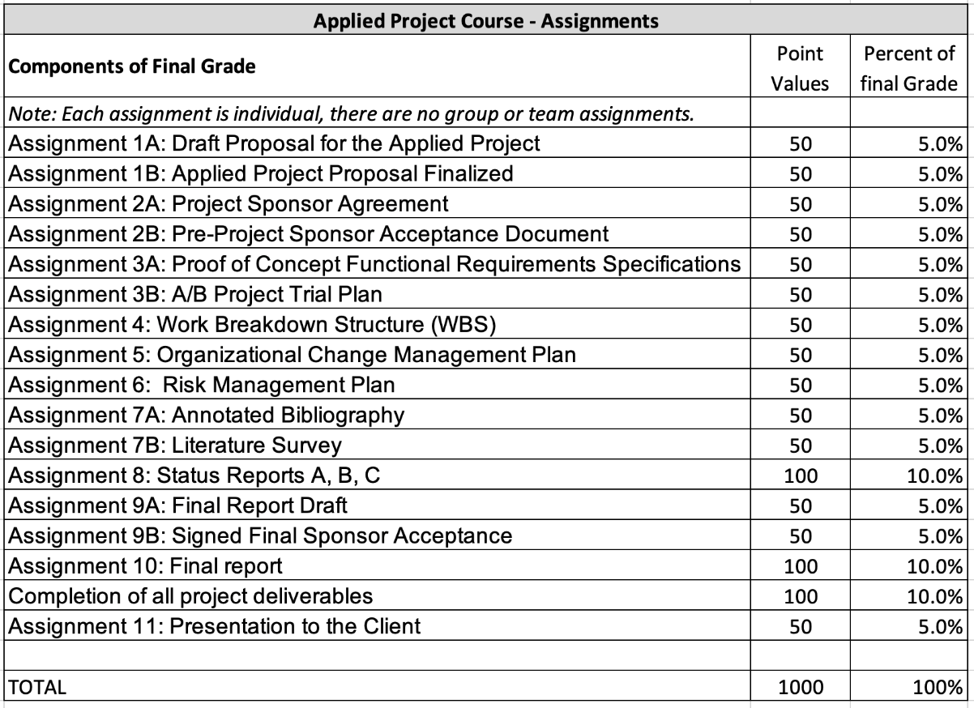

*See the* [*“Grades” section of Academic Policies*](https://www.sps.nyu.edu/homepage/student-experience/policies-and-procedures.html#Graduate1) *for the complete grading policy, including the letter grade conversion, and the criteria for a grade of incomplete, taking a course on a pass/fail basis, and withdrawing from a course.*

**NYU SPS Graduate Grading Scale**

|  |  |  |  |
| --- | --- | --- | --- |
| **A** | 95-100 | 4.000 | **Exceptional:** Demonstrates exceptional mastery of all learning outcomes of the course and thorough and complete understanding of all concepts. |
| **A-** | 90-94 | 3.667 | **Excellent:** Demonstrates highly competent mastery of all learning outcomes of the course and strong understanding of all concepts. |
| **B+** | 87-89 | 3.333 | **Very Good; exceeds course standards:** Demonstrates mastery of all learning outcomes of the course and understanding of core concepts. |
| **B** | 83-86 | 3.000 | **Good; meets course standards:** Demonstrates mastery of some learning outcomes; understanding of some core concepts could be improved. |
| **B-** | 80-82 | 2.667 | **Somewhat Satisfactory;** meets some course standards and requires improvement: Demonstrates basic understanding of some learning outcomes; improved understanding of all core concepts is needed. |
| **C+** | 77-79 | 2.333 | **Less than Satisfactory; requires significant improvement:** Demonstrates partial understanding of all learning outcomes and core concepts; requires significant improvement. |
| **C** | 73-76 | 2.000 | **Unsatisfactory; requires substantial improvement:** Demonstrates partial understanding of some learning outcomes and core concepts; requires substantial improvement. |
| **C-** | 70-72 | 1.667 | **Unsatisfactory; requires extensive improvement:** Demonstrates poor understanding of all learning outcomes and core concepts; requires extensive improvement. |
| **F** | Below 70 |  | **Fail:** Demonstrates minimal to no understanding of all key learning outcomes and core concepts; work is unworthy of course credit towards the degree. |
| **P** |  |  | **Passing:** If a Pass/Fail grade is allowed, the choice of pass/fail must be made prior to the completion of the fifth week of the term. |

**Course Outline**

**Start/End Dates:** 09/032024 - 12/10/2024

**Time:** 6:20 PM - 8:55 PM

**No Class Date(s):** 10/15/2024

Special Notes:

**Session 1 - 09/03/24**

**Topic Description:** Selecting and Planning the Applied Project

The Applied Project Proposal

The steps to a successful applied project

The Applied Project Workflow: Deliverables, milestones, and key dates

Researching appropriate projects

Selecting the proposed project idea

Preparing the project proposal and understanding its elements

Due dates for final project completion and submission of the final paper

**Assignments:** None

Each student will also schedule and conduct a project kick-off meeting with their sponsor and the course professor. A template for the meeting will be posted in the Resources section of the course to guide the student in preparing for and conducting this important meeting.

**Session 2 – 09/10/24**

**Topic description** – How to Conduct the Applied Project

Working with your project sponsor

Utilizing the project outline in securing a project sponsor

Project Sponsor Agreement

Use Case development

Reading: Ng, Chapter 1 and Chapter 2 These chapters provide an excellent introduction to IT innovation and the importance of strategic planning. They align well with the course introduction and the process of identifying potential technologies for projects. Chapter 5 This chapter focuses on requirements gathering and user stories, which directly supports the use case development and design thinking.

**Assignments:**  Assignment 1A - Proposal Draft

**Session 3 – 09/17/24**

**Topic description** – Proof of Concept - requirements specifications

What is a proof of concept?

Creating functional requirement specifications

Reading: Ng, Chapter 5 and Chapter 6 These chapters cover requirements analysis and architectural design, providing valuable insights for developing a comprehensive FRS. Chapter 7 and Chapter 8 These chapters discuss development methodologies and integration strategies, which are crucial for planning an effective PoC.

**Assignments:** Assignment 1B- Proposal Final

**Session 4 – 09/24/24**

**Topic description –** Planning to Project Trial and WBS

The research question and hypothesis

A/B testing

Design of the Project Trial

Project Plan and Work Breakdown Structure (WBS)

Reading: Ng, Chapter 8 and Chapter 10 These chapters focus on testing strategies and deployment planning, which are essential for trial planning and execution.

**Assignments:** Assignment 2A Sponsor Agreement and 2B Acceptance documents

**Session 5 – 10/01/24**

**Topic description –** Organizational Change and Risk Analysis Plans

Planning for Organizational change

The Organizational Change Management plan and its components

The Change Management process

Risk Management Planning

Risk recognition and activating your risk mitigation strategy

**Assignments:**  Assignment 3A – PoC Functional Requirements Specifications

**Session 6 – 10/08/24**

**Topic description –** The Literature Survey

Purpose of the literature survey

Sources of information for the literature survey

How to conduct the literature survey

How to organize and present your findings

**Assignments**: Assignment 3B: A/B Trail Design

Assignment 8A – Progress Report Objective 1

**Session 7 – 10/22/24**

**Topic description –** Final Report and Presentation

Organizing and writing your final paper

**Reviews of the format of the final report and client presentation.**

Reading: Ng, Chapter 11 and Chapter 12 These chapters cover data analysis, performance evaluation, and future planning, aligning well with the evaluation and reporting phase of the course.

**Assignments:** Assignment 4 - WBS

**Session 8 – 10/29/24**

**Topic description –** Live Coaching/Mentoring Session

Bring your questions, project issues and problems to class and we will devote time to discuss and resolve each student’s project problems, difficulties, or questions.

**Assignments:** Assignment 5 – Organizational Change Plan

**Session 9 – 11/05/24**

**Topic description –** Synchronous coaching

The remaining 7 sessions will be online Asynchronous. During this time, students are expected to complete any outstanding assigned course deliverables and will commence their individual project activities.

**Assignments:**  Assignment 6 Risk Management Plan

Assignment 8B – Status report Objective 2

**Session 10 – 11/12/24**

**Topic description –** Synchronous coaching

The remaining sessions will be online synchronous coaching sessions. During this time, students are expected to complete any outstanding assigned course deliverables and will continue their individual project activities.

**Assignments:**  Assignment 7A Annotated Bibliography and 7B – Literature Survey

**Assignments:**

**Session 11 – 11/19/24**

**Topic description** – Synchronous coaching

The remaining sessions will be online synchronous coaching sessions. During this time, students are expected to complete any outstanding assigned course deliverables and will continue their individual project activities.

**Assignments:**  NONE

**Session 12 – 11/26/24**

**Topic description –** Review of Final Deliverables **and** Synchronous coaching

Online session to review final deliverables.

**Assignments:**  Assignment 8C - Status Report Objective 3

**Session 13 – 12/03/24**

**Topic description –** Synchronous coaching

The remaining sessions will be online synchronous coaching sessions. During this time, students are expected to complete any outstanding assigned course deliverables and will commence their individual project activities.

**Assignments:**  Assignment 9 - Draft of Final Report

**Session 14 – 12/10/24**

**Topic description –** Final Presentations

FINAL REPORT DUE and FINAL MEETING WITH CLIENT

**Assignments:**  Assignment 10 - Final Report

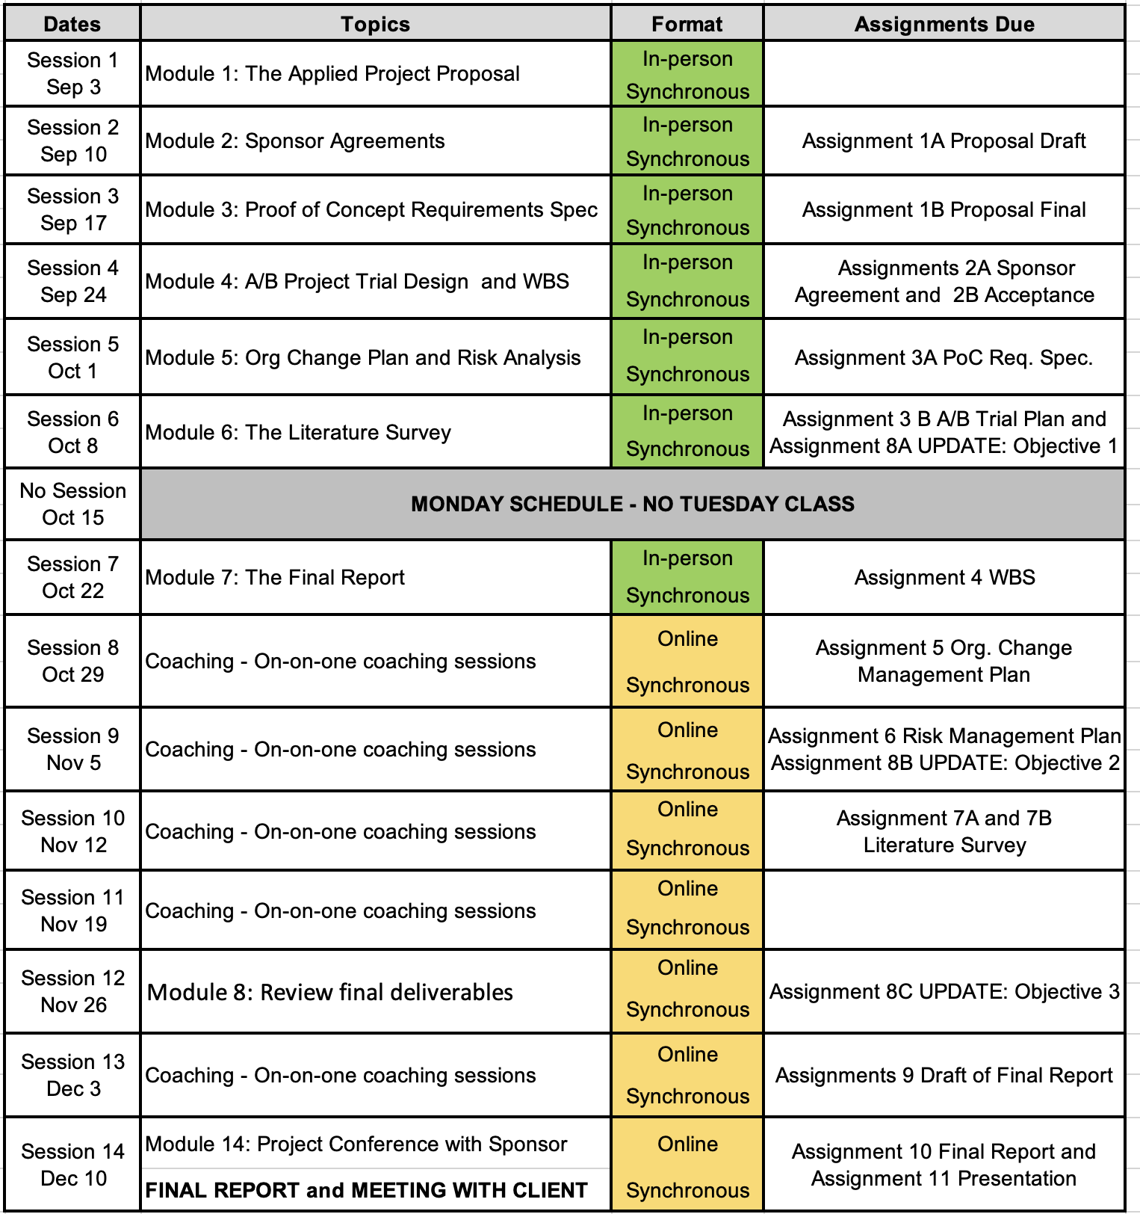

**NOTES:**

The syllabus may be modified to better meet the needs of students and to achieve the learning outcomes.

The School of Professional Studies (SPS) and its faculty celebrate and are committed to inclusion, diversity, belonging, equity, and accessibility (IDBEA), and seek to embody the IDBEA values. The School of Professional Studies (SPS), its faculty, staff, and students are committed to creating a mutually respectful and safe environment (*from the* [*SPS IDBEA Committee*](https://www.sps.nyu.edu/homepage/about-us/idbea/about-idbea.html)).

**New York University School of Professional Studies Policies**

1. Policies - You are responsible for reading, understanding, and complying with [University Policies and Guidelines](http://www.nyu.edu/about/policies-guidelines-compliance.html), [NYU SPS Policies and Procedures](http://sps.nyu.edu/academics/academic-policies-and-procedures.html), and [Student Affairs and Reporting](https://www.nyu.edu/about/policies-guidelines-compliance/policies-and-guidelines/student-services.html).

2. Learning/Academic Accommodations - New York University is committed to providing equal educational opportunity and participation for students who disclose their dis/ability to the [Moses Center for Student Accessibility](https://www.nyu.edu/students/communities-and-groups/student-accessibility.html). If you are interested in applying for academic accommodations, contact the [Moses Center](https://www.nyu.edu/students/communities-and-groups/student-accessibility/academic.html) as early as possible in the semester. If you already receive accommodations through the Moses Center, request your accommodation letters through the [Moses Center Portal](https://www.nyu.edu/students/communities-and-groups/student-accessibility.html) as soon as possible ([mosescsa@nyu.edu](mailto:mosescsa@nyu.edu) | 212-998-4980).

3. Health and Wellness - To access the University's extensive health and mental health resources, contact the [NYU Wellness Exchange](https://www.nyu.edu/students/health-and-wellness/wellness-exchange.html). You can call its private hotline (212-443-9999), available 24 hours a day, seven days a week, to reach out to a professional who can help to address day-to-day challenges as well as other health-related concerns.

4. Student Support Resources - There are a range of resources at SPS and NYU to support your learning and professional growth. For a complete list of resources and services available to SPS students, visit the [NYU SPS Office of Student Affairs site](https://www.sps.nyu.edu/homepage/student-experience/resources-and-services.html).

5. Religious Observance - As a nonsectarian, inclusive institution, NYU policy permits members of any religious group to absent themselves from classes without penalty when required for compliance with their religious obligations. Refer to the [University Calendar Policy on Religious Holidays](https://www.nyu.edu/about/policies-guidelines-compliance/policies-and-guidelines/university-calendar-policy-on-religious-holidays.html) for the complete policy.

6. Academic Integrity and Plagiarism - You are expected to be honest and ethical in all academic work. Moreover, you are expected to demonstrate how what you have learned incorporates an understanding of the research and expertise of scholars and other appropriate experts; and thus recognizing others' published work or teachings—whether that of authors, lecturers, or one's peers—is a required practice in all academic projects.

Plagiarism involves borrowing or using information from other sources without proper and full credit. You are subject to disciplinary actions for the following offenses which include but are not limited to cheating, plagiarism, forgery or unauthorized use of documents, and false form of identification

[Turnitin](https://www.nyu.edu/servicelink/KB0018471), an originality detection service in NYU Brightspace, may be used in this course to check your work for plagiarism.

Read more about academic integrity policies at the NYU School of Professional Studies on the [Academic Policies for NYU SPS Students](https://www.sps.nyu.edu/homepage/student-experience/policies-and-procedures.html) page.

7. Use of Third-Party Tools - During this class, you may be required to use non-NYU apps/platforms/software as a part of course studies, and thus, will be required to agree to the “Terms of Use” (TOU) associated with such apps/platforms/software.

These services may require you to create an account but you can use a pseudonym (which may not identify you to the public community, but which may still identify you by IP address to the company and companies with whom it shares data).

You should carefully read those terms of use regarding the impact on your privacy rights and intellectual property rights. If you have any questions regarding those terms of use or the impact on the class, you are encouraged to ask the instructor prior to the add/drop deadline.